**Assignment 1** -**facebook Analysis**

CREATE TABLE facebook(userid int,age int,dob_day int,dob_year int,dob_month int,gender varchar (10),tenure int,friend_count int,friendships_initiated int,

likes int,likes_received int,mobile_likes int,mobile_likes_received int,www_likes int,www_likes_received int) ROW FORMAT DELIMITED FIELDS TERMINATED BY ',';

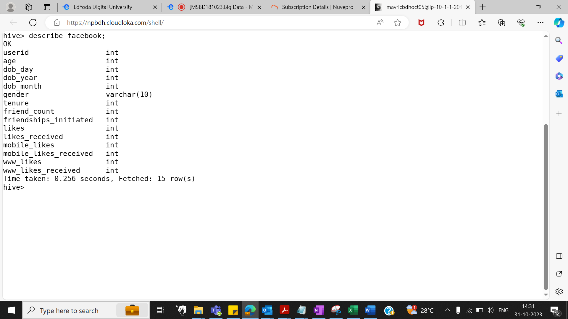

**LOAD DATA LOCAL INPATH 'pseudofacebook.csv' INTO TABLE facebook;**

**Q1: Find out the total no of users in the dataset .**

select count(*) form facebook;

select count(DISTINCT userid) from facebook;`

Ans 99003

**Q2: Find out the no of users above the age of 25**

select count(*) from facebook where age > 25;

Stage-Stage-1: Map: 1 Reduce: 1 Cumulative CPU: 10.01 sec HDFS Read: 5327068 HDFS Write: 105 HDFS EC Read: 0 SUCCESS

Total MapReduce CPU Time Spent: 10 seconds 10 msec

OK

56676

**Q3.Do male face book users tend to have more friends or female users**

select gender,sum(friend_count) from facebook group by gender;

OK

NA 32272

female 9740258

male 9666787

**Q4: How many likes do young people receive on facebook as opposed to old people**

select 'Young' as people ,sum(likes_received) as total_likes from facebook where age <= 18

union

select 'OLD' as people ,sum(likes_received) as total_likes from facebook where age > 18)a;

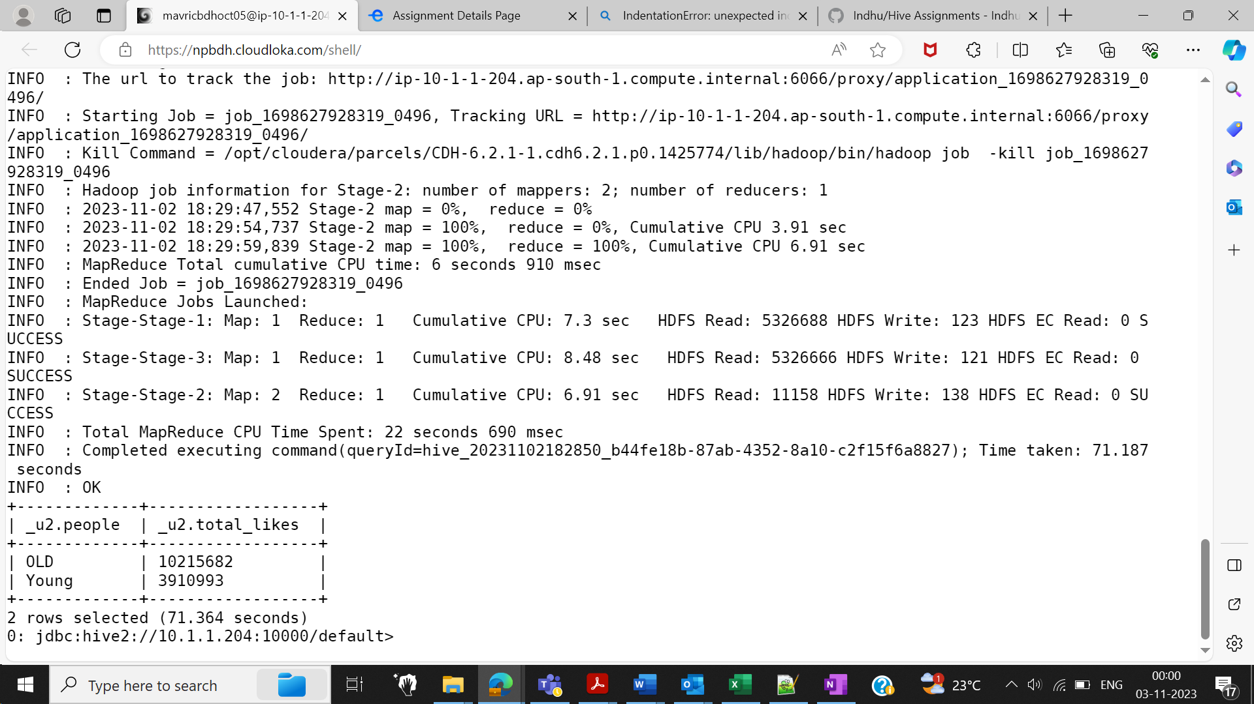

select sum(likes_received) from facebook where age between 21 and 115;

+----------+

| _c0 |

+----------+

| 8015964 |

+----------+

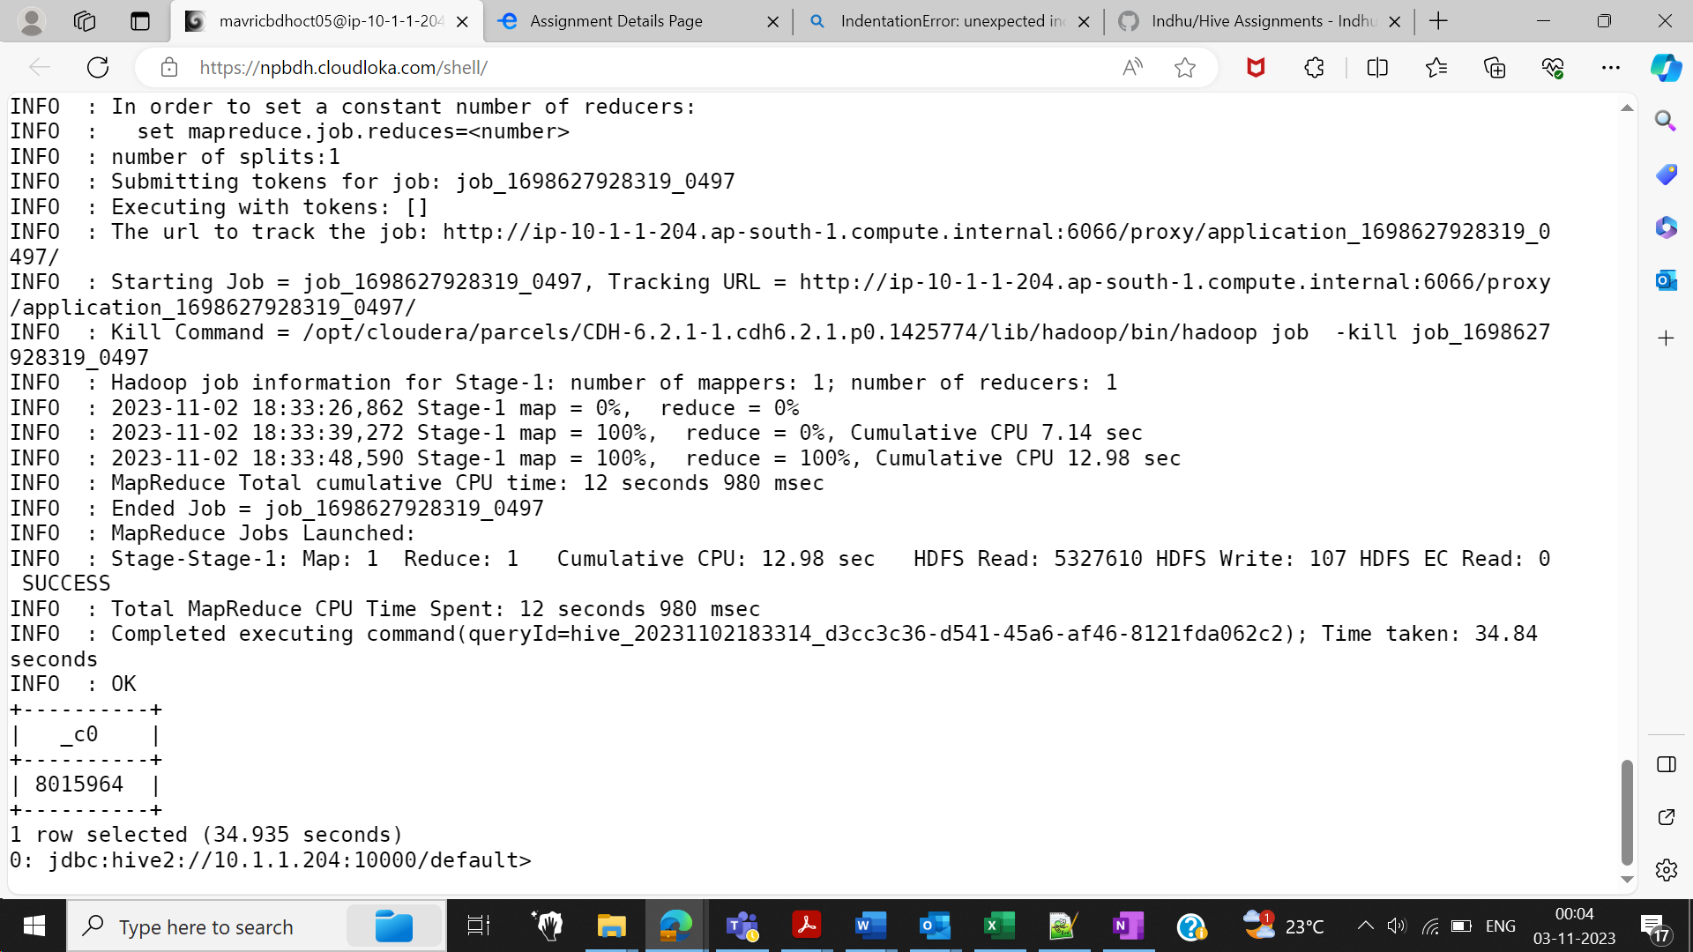

**Q5: Find out the count of facebook users for each birthday month**

select dob_month,count(userid) as count_users from facebook group by dob_month;

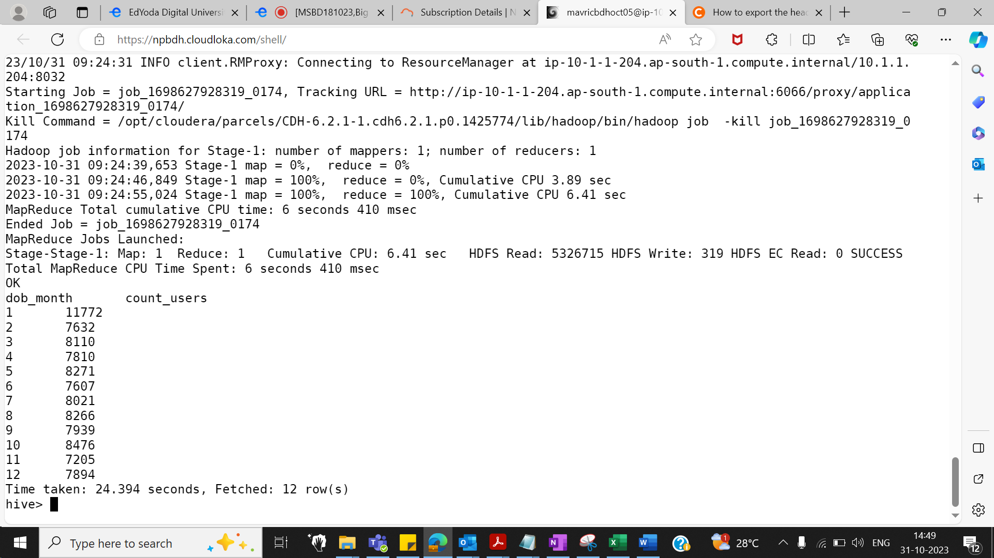

**Q6:Do young members use mobile phones or computers for facebook browsing**

select sum(mobile_likes) as total_mobile_likes ,sum(www_likes) as total_www_likes from facebook where age<=18;

+---------------------+------------------+

| total_mobile_likes | total_www_likes |

+---------------------+------------------+

| 2406372 | 1187654 |

+---------------------+------------------+

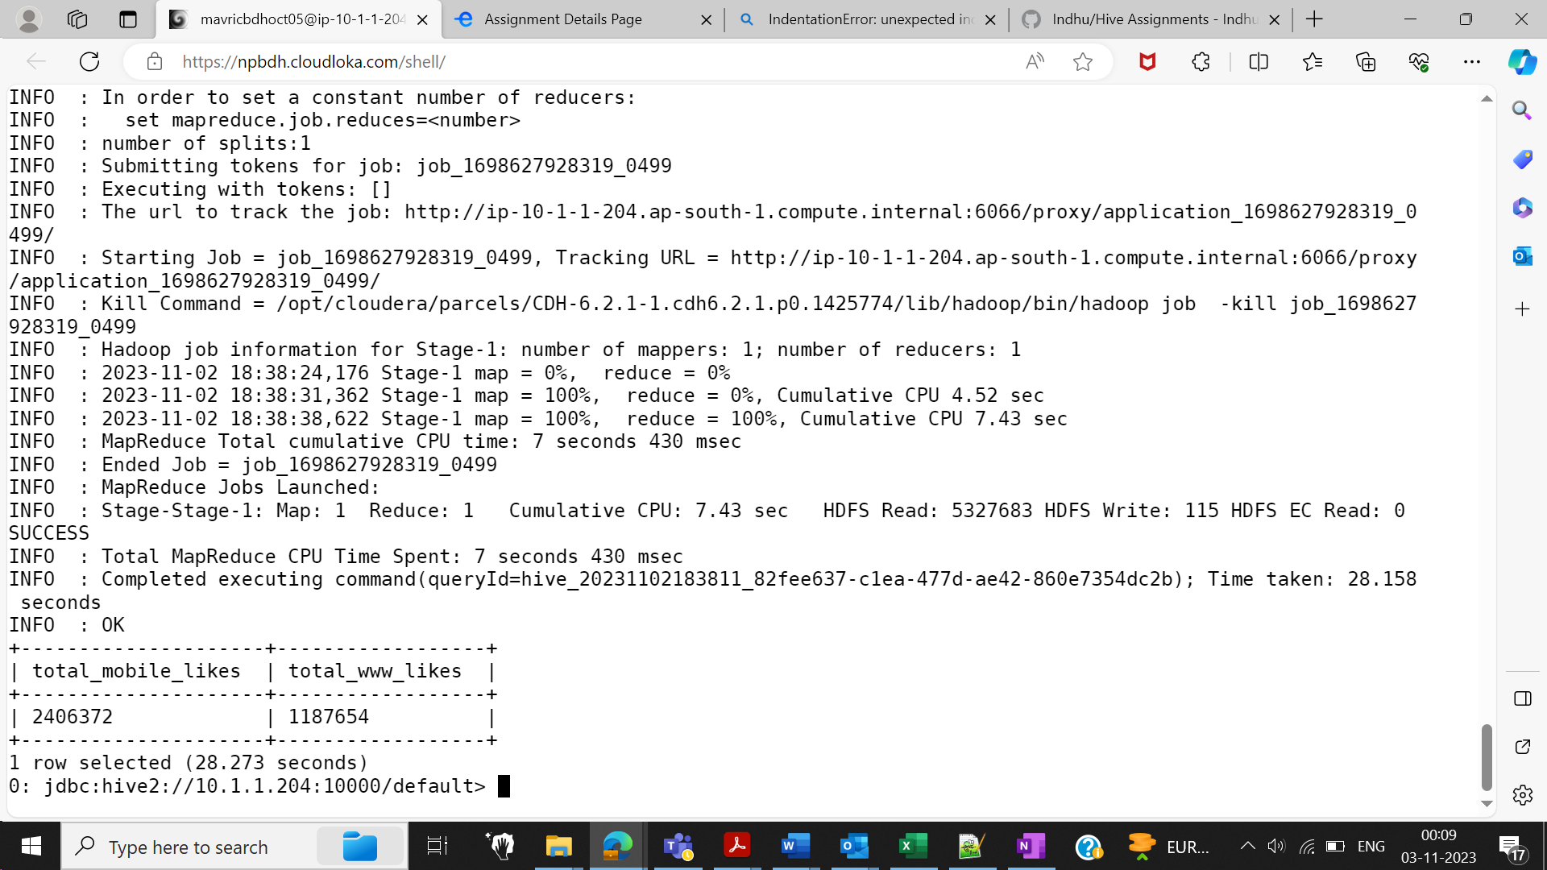

**Q7:Do adult members use mobile phones or computers for facebook browsing**

Select sum(mobile_likes) as total_mobile_likes ,sum(www_likes) as total_www_likes from facebook where age >18;

+---------------------+------------------+

| total_mobile_likes | total_www_likes |

+---------------------+------------------+

| 8099460 | 3758776 |

+---------------------+------------------+

